SAGE 300 ERP · INVENTORY CONTROL

Location Transfers
User Guide

Transferring inventory items between locations (stores / warehouses)
Application | Sage 300 ERP
Module | Inventory Control — I/C Transactions
Task | Location Transfers
Audience | Inventory & Warehouse Users
Version | 1.0
Date | June 2026

Contents

1. Overview 3
2. Before You Begin 3
3. Step-by-Step Instructions 4
Step 1 — Open the Transfers Screen 4
Step 2 — Review the Transfers Screen 4
Step 3 — Enter the Header Information 5
Step 4 — Click in the Item Area 6
Step 5 — Enter the Item and Locations 6
Step 6 — Enter the Quantities 7
Step 7 — Add More Items 8
Step 8 — Post or Save the Transfer 8
4. Example of a Completed Transfer 9
5. Quick Reference 9

1. Overview
A location transfer moves inventory items from one location to another within Sage 300. In Sage, a location is the term used for a store, warehouse, or any other stocking point where inventory is held.
This guide walks through the full process of transferring inventory items between locations using the Inventory Control Transfers screen — from opening the screen and entering header details, through adding items and quantities, to posting the completed transfer.
When to use this
Use a location transfer whenever stock physically moves between two of your locations and the inventory records need to reflect that move — for example, sending parts from a central warehouse to a site store.

2. Before You Begin
Make sure the following are in place before starting a transfer:
- You have access to the Inventory Control module, specifically Inventory Control → I/C Transactions.
- The item you want to move already exists in Inventory Control and has stock available in the From Location.
- Both the source (From Location) and destination (To Location) are valid, set-up locations.

3. Step-by-Step Instructions

Step 1 — Open the Transfers Screen
Inventory Control → I/C Transactions → Transfers
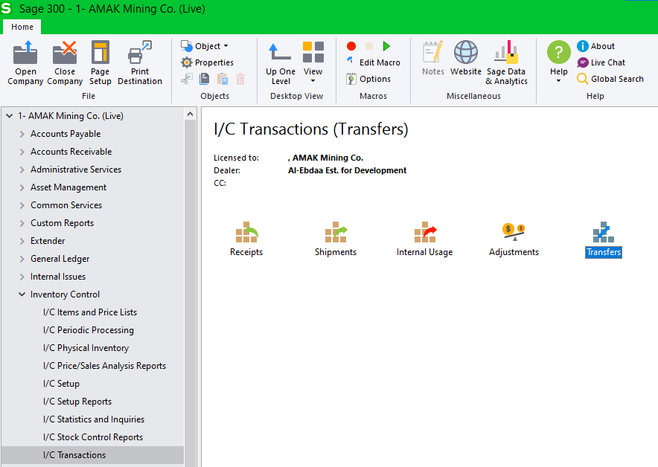
Figure 1. The Transfers icon under Inventory Control → I/C Transactions.

Step 2 — Review the Transfers Screen
The Transfers screen opens. The upper area holds the document header information; the grid in the middle is where you enter the items to transfer; and the panel at the bottom shows quantity information for the selected item and locations.
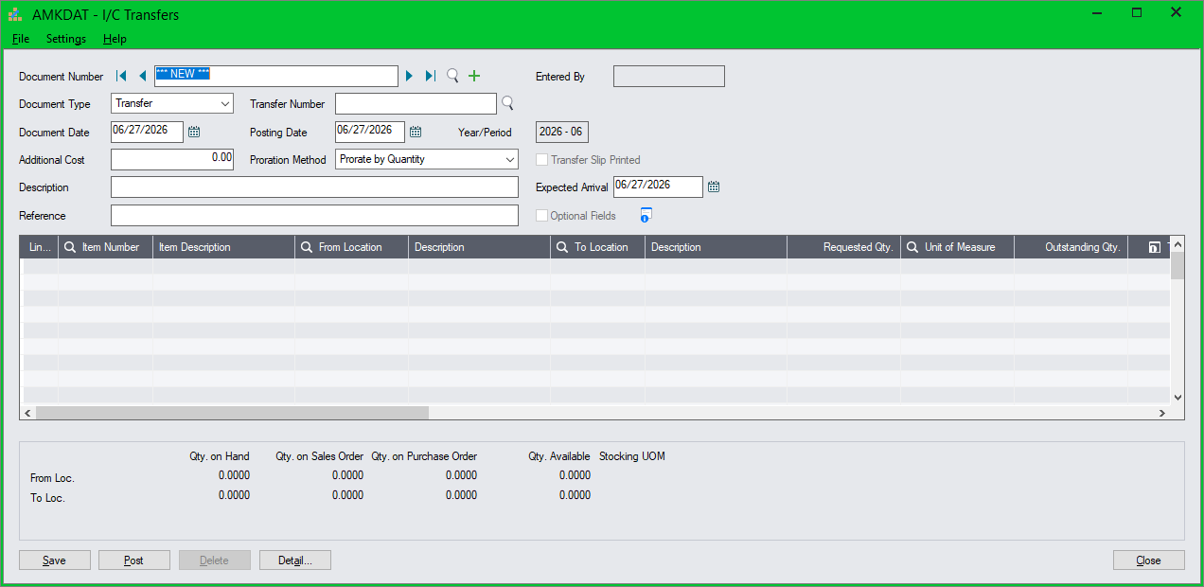
Figure 2. The I/C Transfers screen, ready for a new transfer.

Step 3 — Enter the Header Information
Complete the header fields at the top of the screen — the Date, Description, and Reference information that identify the transfer.
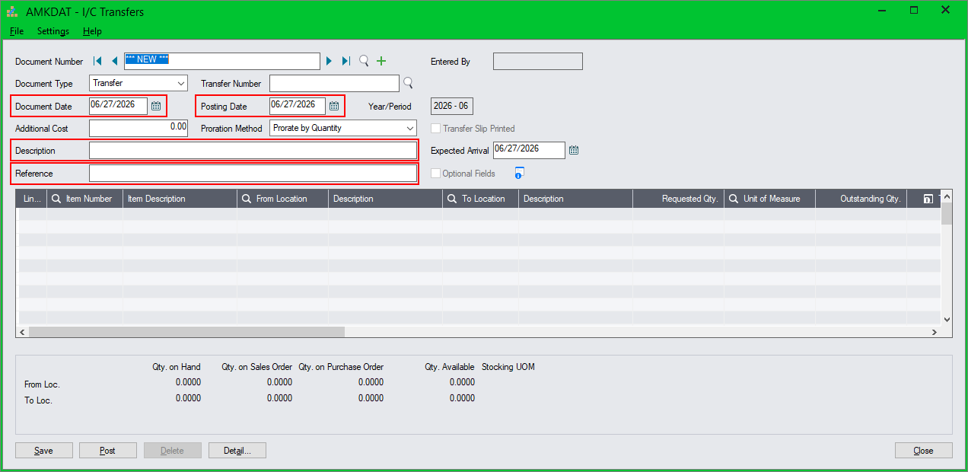
Figure 3. Entering the document date, description, and reference.
Field | Description
Document Date | Defaults to the session date. This is the date of the transfer document.
Posting Date | Defaults to the Document Date. Controls the period the transaction posts to.
Description | A general description of the transfer.
Reference | Documents the source or reason for the transfer (for example, a request or ticket number).

Step 4 — Click in the Item Area
Click into the item grid in the middle of the screen to begin adding the items you want to transfer.
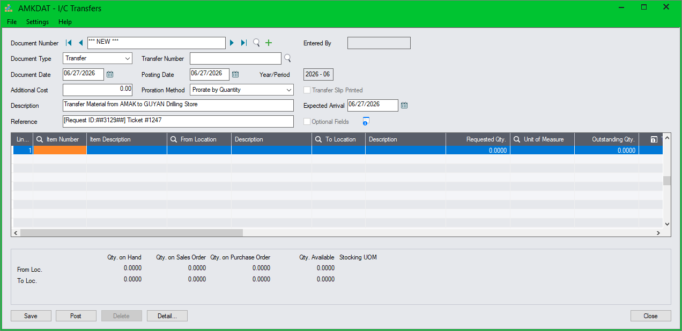
Figure 4. Clicking into the item grid to start the first line.

Step 5 — Enter the Item and Locations
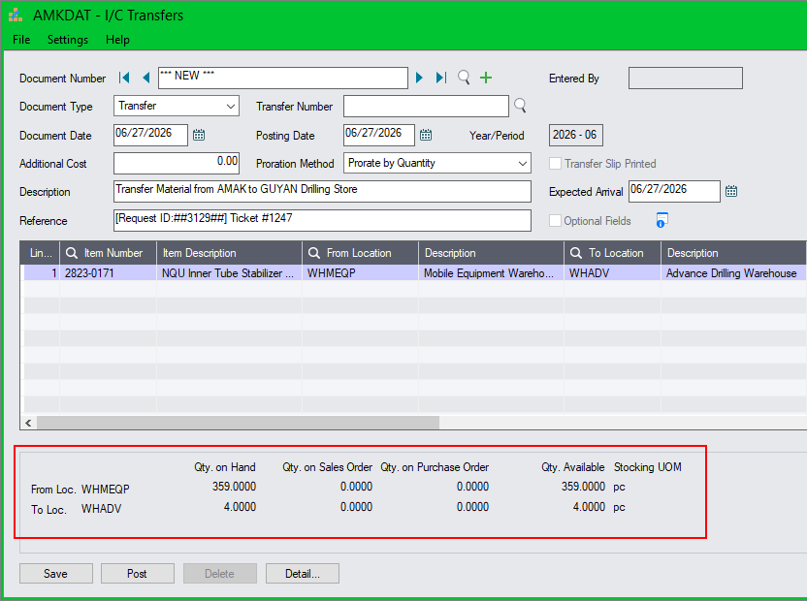
Figure 5. Entering the item number with its From and To locations.

Step 6 — Enter the Quantities
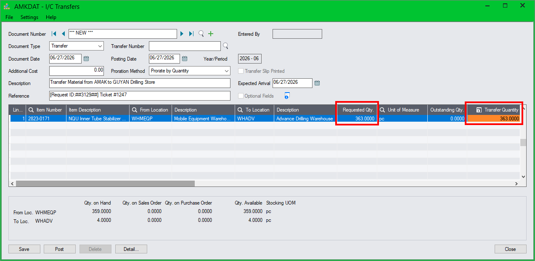
Figure 6. Entering the requested and transfer quantities.
If the quantity is not available
If the Transfer Quantity exceeds the quantity available in the From Location, Sage 300 displays an error and the transfer cannot proceed for that line until the quantity is corrected.
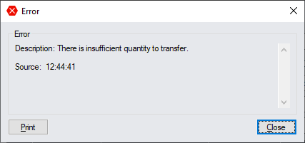
Figure 7. The error shown when the transfer quantity exceeds available stock.

Step 7 — Add More Items
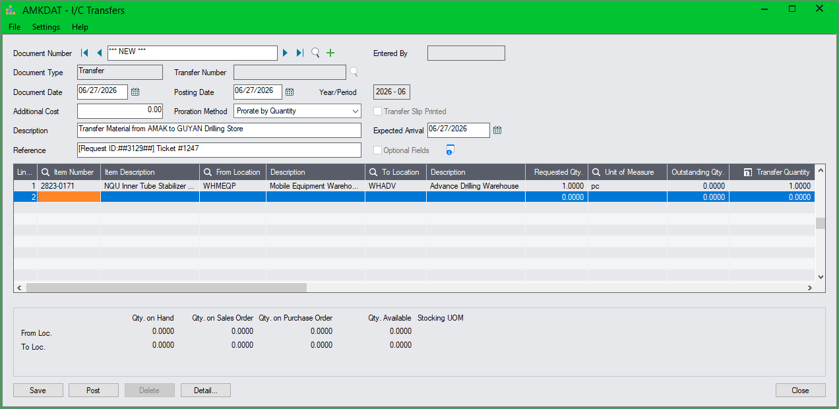
Figure 8. Pressing Insert to add another item line to the transfer.

Step 8 — Post or Save the Transfer
Once all items have been entered, complete the transfer:
- Click Post to post the transfer immediately.
- Or click Save to save the transfer and post it later.
Document number & when it takes effect
On posting, the system assigns a document number in the format TRF-nnnnn.
The transfer takes effect — and inventory balances update — only once the transaction is posted.

4. Example of a Completed Transfer
The screen below shows a completed, posted transfer. Note the assigned document number, the populated header information, and the list of transferred items with their From and To locations and quantities.
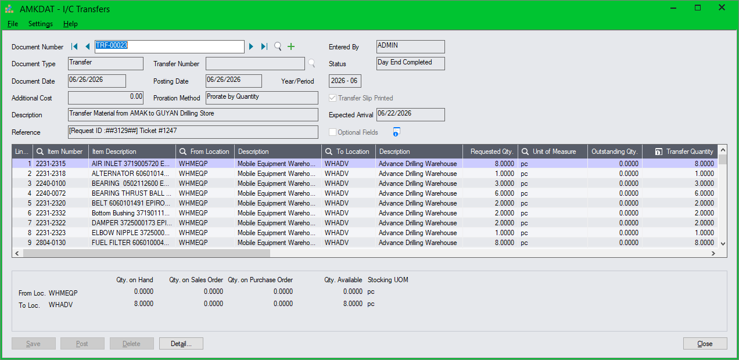
Figure 9. A completed transfer showing document number TRF-00023 with multiple posted item lines.

5. Quick Reference
The full process at a glance:
- Open Inventory Control → I/C Transactions → Transfers.
- Enter the Document Date, Description, and Reference.
- Click into the item grid.
- Enter the Item Number, From Location, and To Location.
- Enter the Requested Qty and Transfer Quantity.
- Press Insert to add more items as needed.
- Click Post to post now, or Save to post later.

